PUPIL MENTAL HEALTH AND WELLBEING POLICY

Document Control
This document has been approved for operation within: | All Trust Establishments
Date effective from | September 2023
Date next review due by | September 2026
Review period | 3 Years

CONTENTS
1.0 AIMS 4
2.0 LEGISLATION AND GUIDANCE 4
3.0 ROLES AND RESPONSIBILITIES 4
4.0 PROCEDURE TO FOLLOW IN A CASE OF ACUTE MENTAL HEALTH CRISIS 5
5.0 WARNING SIGNS 6
6.0 MANAGING DISCLOSURES 6
7.0 CONFIDENTIALITY 6
8.0 SUPPORTING PUPILS 7
9.0 SUPPORTING AND COLLABORATING WITH PARENTS/CARERS 9
10.0 SUPPORTING PEERS 9
11.0 SIGNPOSTING 10
12.0 WHOLE SCHOOL APPROACH TO PROMOTING MENTAL HEALTH AWARENESS 10
13.0 TRAINING 10
14.0 SUPPORT FOR STAFF 10
15.0 MONITORING ARRANGEMENTS 11

AIMS
  - At Coal Clough Academy, we are committed to supporting the mental health and wellbeing of pupils, parents, carers, staff and other stakeholders.
1.2 This policy focuses on pupils' mental health and wellbeing. It aims to:
  - Provide guidance to staff on their role in supporting pupils' mental health and wellbeing, including how they can foster and maintain an inclusive culture in which pupils feel able to talk about and reflect on their experiences of mental health.
  - Support staff to identify and respond to early warning signs of mental health issues.
  - Inform pupils and their parents/carers about the support they can expect from our school in respect of pupils' mental health and wellbeing, and provide them with access to resources.
1.3 It should be read alongside:
- SEND policy
- Behaviour policy
- Anti-bullying policy
- Safeguarding policy

2.0 LEGISLATION AND GUIDANCE
2.1 This policy was written with regard to:
  - The Equality Act 2010
  - The Data Protection Act 2018
  - Articles 3 and 23 of the UN Convention on the Rights of the Child

3.0 ROLES AND RESPONSIBILITIES
3.1 All staff are responsible for promoting positive mental health and wellbeing across our school and for understanding risk factors. If any members of staff are concerned about a pupil’s mental health or wellbeing, they should inform the Designated Safeguarding Lead (DSL), Nathanial Eatwell.
3.2 Certain members of staff have extra duties to lead on mental health and wellbeing in school. These members of staff include:
- Headteacher – Holly Clarke
- Designated safeguarding lead (DSL) – Nathanial Eatwell
- Special educational needs co-ordinator (SENCO) – Richard SENCo
- Mental health lead – Nathanial Eatwell
- Attendance lead – Jo Green

PROCEDURE TO FOLLOW IN A CASE OF ACUTE MENTAL HEALTH CRISIS

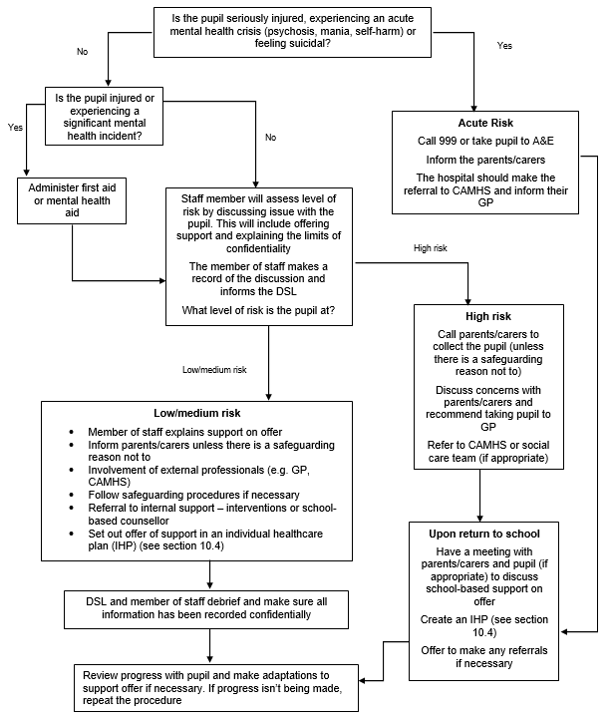

5.0 WARNING SIGNS
5.1 All staff will be on the lookout for signs that a pupil's mental health is deteriorating. Some warning signs include:
Changes in:
- Mood or energy level
- Eating or sleeping patterns
- Attitude in lessons or academic attainment
- Level of personal hygiene
- Social isolation
- Poor attendance or punctuality
- Expressing feelings of hopelessness, anxiety, worthlessness or feeling like a failure
- Abuse of drugs or alcohol
- Rapid weight loss or gain
- Secretive behaviour
- Covering parts of the body that they wouldn’t have previously
- Refusing to participate in P.E. or being secretive when changing clothes
- Physical pain or nausea with no obvious cause
- Physical injuries that appear to be self-inflicted
- Talking or joking about self-harm or suicide

6.0 MANAGING DISCLOSURES
6.1 If a pupil makes a disclosure about themselves or a peer to a member of staff, staff should remain calm, non-judgmental and reassuring.
6.2 Staff will focus on the pupil’s emotional and physical safety, rather than trying to find out why they are feeling that way or offering advice.
6.3 Staff will always follow our school’s safeguarding policy and pass on all concerns to the DSL. All disclosures are recorded and stored in the pupil’s confidential child protection file.
6.4 When making a record of a disclosure, staff will include:
- The full name of the member of staff who is making the record
- The full name of the pupil(s) involved
- The date, time and location of the disclosure
- The context in which the disclosure was made
- Any questions asked or support offered by the member of staff

7.0 CONFIDENTIALITY
7.1 Staff will not promise a pupil that they will keep a disclosure secret – instead they will be upfront about the limits of confidentiality.
7.2 A disclosure cannot be kept secret because:
- Being the sole person responsible for a pupil’s mental health could have a negative impact on the member of staff’s own mental health and wellbeing
- The support put in place for the pupil will be dependent on the member of staff being at school
- Other staff members can share ideas on how to best support the pupil in question
7.3 Staff should always share disclosures with at least 1 appropriate colleague. This will usually be the DSL. If information needs to be shared with other members of staff or external professionals, it will be done on a need-to-know basis.
7.4 Before sharing information disclosed by a pupil with a third party, the member of staff will discuss it with the pupil and explain:
- Who they will share the information with
- What information they will share
- Why they need to share that information
7.5 Staff will attempt to receive consent from the pupil to share their information, but the safety of the pupil comes first.
7.6 Parents/carers will be informed unless there is a child protection concern. In this case the child protection & safeguarding policy will be followed.
7.7 Process for managing confidentiality around disclosures
- Pupil makes a disclosure
- Member of staff offers support
- Member of staff explains the issues around confidentiality and rationale for sharing a disclosure with DSL
- Member of staff will attempt to get the pupil’s consent to share – if no consent is given, explain to the pupil who the information will be shared with and why
- Member of staff will record the disclosure and share the information with the chosen elected member of staff
- The DSL will inform the parent/carer (if appropriate)
- Any other relevant members of staff or external professionals will be informed on a need-to-know basis

8.0 SUPPORTING PUPILS
8.1 Baseline support for all pupils
As part of our school’s commitment to promoting positive mental health and wellbeing for all pupils, our school offers support to all pupils by:
- Raising awareness of mental health during assemblies, tutor time, PSHE and appropriate awareness days
- Signposting all pupils to sources of online support on our school website
- Having open discussions about mental health during lessons
- Providing pupils with avenues to provide feedback on any elements of our school that is negatively impacting their mental health
- Appointing a senior mental health lead with a strategic oversight of our whole school approach to mental health and wellbeing – Nathanial Eatwell
- Offering pastoral support, e.g. through the work of the SEND and Pastoral Teams

8.2 Assessing what further support is needed
If a pupil is identified as having a mental health need, the Safeguarding Team will take a graduated and case-by-case approach to assessing the support our school can provide, further to the baseline support detailed above in section 8.1.
Our school will offer support in cycles of:
- Assessing what the pupil’s mental health needs are
- Offering support through appropriate channels in liaison with parents or carers
- Taking action to make referrals where appropriate

8.3 Internal mental health interventions
Where appropriate, a pupil will be offered support that is tailored to their needs as part of the graduated approach detailed above. The support offered at our school includes:
- Small group provision
- Access to Mental Health First Aiders
- Access to counsellors 1-1
- Small group work on specific issues (i.e. self-harm, anxiety)

8.4 Making external referrals
If a pupil’s needs cannot be met by the internal offer our school provides, our school will make, or encourage parents/carers to make, a referral for external support.
- A pupil could be referred to:
- Their GP or a paediatrician
- CAMHS/ELCAS
- Mental health charities (e.g. Samaritans, Mind, Young Minds, Kooth)
- Local counselling services

9.0 SUPPORTING AND COLLABORATING WITH PARENTS/CARERS
9.1 We will work with parents/carers to support pupils’ mental health by:
- Asking parents/carers to inform us of any mental health needs their child is experiencing, so we can offer the right support
- Informing parents/carers of mental health concerns that we have about their child
- Engaging with parents/carers to understand their mental health and wellbeing issues, as well as that of their child, and support them accordingly to make sure there is holistic support for them and their child
- Highlighting sources of information and support about mental health and wellbeing on our school website, including the mental health and wellbeing policy
- Liaising with parents/carers to discuss strategies that can help promote positive mental health in their child
- Providing guidance to parents/carers on navigating and accessing relevant local mental health services or other sources of support (e.g. parent/carer forums)
- Keeping parents/carers informed about the mental health topics their child is learning about in PSHE, and share ideas for extending and exploring this learning at home
9.2 When informing parents/carers about any mental health concerns we have about their child, we will endeavour to do this face-to-face.
9.3 These meetings can be difficult, so our school will ensure that parents/carers are given time to reflect on what has been discussed, and that lines of communication are kept open at the end of the meeting.
9.4 A record of what was discussed, and action plans agreed upon in the meeting will be recorded and added to the pupil’s confidential record.

10.0 SUPPORTING PEERS
10.1 Watching a friend experience poor mental health can be very challenging for pupils. Pupils may also be at risk of learning and developing unhealthy coping mechanisms from each other.
10.2 We will offer support to all pupils impacted by mental health directly and indirectly. We will review the support offered on a case-by-case basis. Support might include:
- Strategies they can use to support their friends
- Things they should avoid doing/saying
- Warning signs to look out for
- Signposting to sources of external support

11.0 SIGNPOSTING

11.1 Sources of support are displayed around our school and linked to on our school website, so pupils and parents/carers are aware of how they can get help.
11.2 The Designated Mental Health Lead will be available to provide further information to pupils and parents/carers if they want to learn more about what support is available.
11.3 Details of in school support and external agencies will be disseminated to pupils through posters in prominent areas of school, through assemblies, within PSHE lessons and through guest speakers form agencies.

12.0 WHOLE SCHOOL APPROACH TO PROMOTING MENTAL HEALTH AWARENESS
12.1 We teach pupil’s about their Mental health in PSHE
We follow the PSHE Association Guidance teaching mental health and emotional wellbeing.
- Pupils are taught to:
- Develop healthy coping strategies
- Challenge misconceptions around mental health
- Understand their own emotional state
- Keep themselves safe
For more information, see our PSHE curriculum
12.2 Creating a positive atmosphere around mental health
Staff will create an open culture around mental health by:
- Discussing mental health with pupils in order to break down stigma
- Encouraging pupils to disclose when their mental health is deteriorating

13.0 TRAINING
13.1 All staff will be offered training so they:
- Have a good understanding of what pupils’ mental health needs are
- Know how to recognise warning signs of mental ill health
- Know a clear process to follow if they identify a pupil in need of help
- Key staff will be identified to receive Mental Health First Aider status to support pupils

14.0 SUPPORT FOR STAFF
14.1 We recognise that supporting a pupil experiencing poor mental health can affect that staff member’s own mental health and wellbeing. To help with this we will:
- Treat mental health concerns seriously
- Offer staff reflection sessions
- Support staff experiencing poor mental health themselves
- Create a pleasant and supportive work environment
- Offer an employee assistance programme – Simply Health

15.0 MONITORING ARRANGEMENTS
15.1 This policy will be reviewed by the Trust every 3 years.
15.2 At every review, the policy will be adopted by the Local Governing Body.

